**Tema 6**

Nume: Pop Maria

Grupa: 232

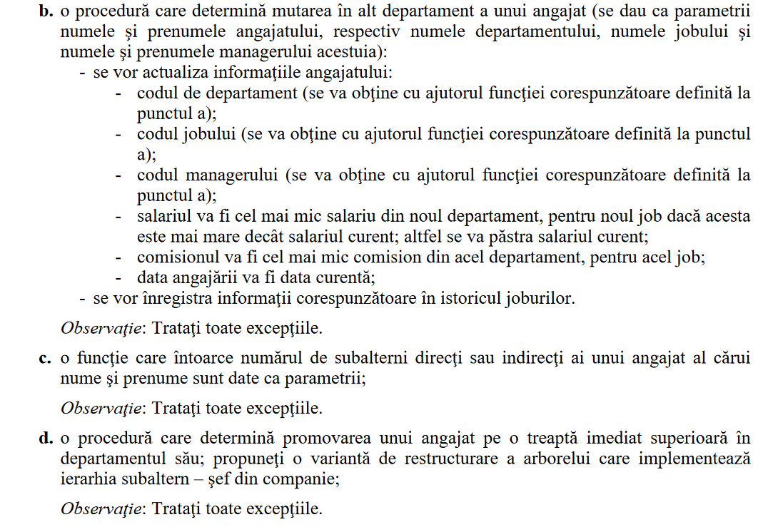

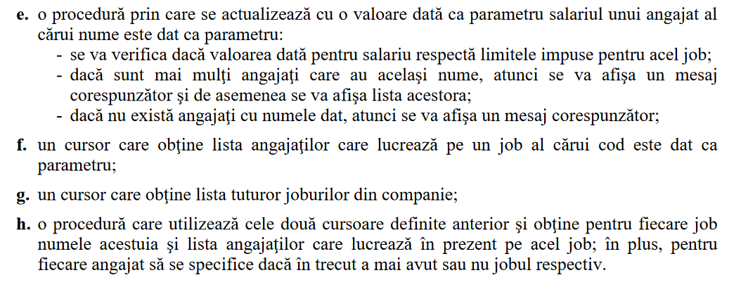

create or replace package pachet1_pm is

-- b)

procedure mutare_angajat(nume employees.last_name%type, prenume employees.last_name%type,

nume_manager employees.last_name%type,

prenume_manager employees.last_name%type,

nume_departament varchar2, nume_job varchar2);

function get_comision(cod_dept employees.department_id%type, cod_job employees.job_id%type)

return employees.commission_pct%type;

-- c)

function numar_subalterni(nume employees.last_name%type, prenume employees.last_name%type)

return number;

-- d)

procedure promovare_angajat(cod_ang employees.employee_id%type);

-- e)

procedure actualizare_salariu(nr number, nume varchar2);

-- f)

cursor lista_angajati(cod_job employees.job_id%type)

return employees%rowtype;

-- g)

cursor lista_joburi return jobs%rowtype is

select *

from jobs;

-- h)

procedure informatii_joburi;

end pachet1_pm;

/

create or replace package body pachet1_pm is

-- f)

cursor lista_angajati(cod_job employees.job_id%type)

return employees%rowtype IS

select *

from employees

where job_id = cod_job;

-- b)

function get_comision(cod_dept employees.department_id%type, cod_job employees.job_id%type)

return employees.commission_pct%type is

comision employees.commission_pct%type;

begin

select min(commission_pct)

into comision

from employees

where department_id = cod_dept and job_id = cod_job;

if comision is null then

comision := 0;

end if;

return comision;

end get_comision;

-- b)

procedure mutare_angajat(nume employees.last_name%type, prenume employees.last_name%type,

nume_manager employees.last_name%type,

prenume_manager employees.last_name%type,

nume_departament varchar2, nume_job varchar2)

is

data_angajare employees.hire_date%type;

comision employees.commission_pct%type;

salariu_nou employees.salary%type;

salariu_curent employees.salary%type;

cod_angajat employees.employee_id%type;

cod_departament employees.department_id%type;

cod_job employees.job_id%type;

cod_manager employees.manager_id%type;

begin

cod_departament := get_cod_dept(nume_departament);

cod_job := get_cod_job(nume_job);

cod_manager := get_cod_manager(nume_manager, prenume_manager);

salariu_nou := get_salariu(cod_departament, cod_job);

select salary, employee_id, hire_date

into salariu_curent, cod_angajat, data_angajare

from emp_pm

where upper(last_name) = upper(nume) and

upper(first_name) = upper(prenume);

if salariu_nou < salariu_curent then

salariu_nou := salariu_curent;

end if;

comision := get_comision(cod_departament, cod_job);

insert into job_history_pm values(cod_angajat, data_angajare, sysdate, cod_job, cod_departament);

update emp_pm

set hire_date = sysdate, job_id = cod_job, salary = salariu_nou,

commission_pct = comision, manager_id = cod_manager, department_id = cod_departament

where employee_id = cod_angajat;

end mutare_angajat;

-- c)

function numar_subalterni(nume employees.last_name%type, prenume employees.last_name%type)

return number is

nr_subalterni number := 0;

cod_ang employees.employee_id%type;

begin

select employee_id

into cod_ang

from employees

where upper(last_name) = upper(nume) and upper(first_name) = upper(prenume);

if cod_ang is null then

raise_application_error(-20004, 'Nu exista angajatul');

end if;

select count(*)

into nr_subalterni

from emp_pm

start with employee_id = cod_ang

connect by prior employee_id = manager_id;

return nr_subalterni;

end numar_subalterni;

-- d)

procedure promovare_angajat(cod_ang employees.employee_id%type)

is

cod_man1 employees.manager_id%type;

cod_man2 employees.manager_id%type;

begin

select manager_id

into cod_man1

from employees

where employee_id = cod_ang;

if cod_man1 is null then

dbms_output.put_line('Nu poate fi promovat');

else

select manager_id

into cod_man2

from employees

where employee_id = cod_man1;

if cod_man2 is null then

update emp_pm

set manager_id = null

where employee_id = cod_ang;

else

update emp_pm

set manager_id = cod_man2

where employee_id = cod_ang;

end if;

dbms_output.put_line('Angajat promovat');

end if;

end promovare_angajat;

-- e)

procedure actualizare_salariu(nr number, nume varchar2)

is

prenume employees.last_name%type;

cod_job employees.job_id%type;

cod_ang employees.employee_id%type;

nr_ang number;

minim number;

maxim number;

begin

select count(*)

into nr_ang

from employees

where upper(last_name) = upper(nume);

if nr_ang = 1 then

select job_id, employee_id

into cod_job, cod_ang

from employees

where upper(last_name) = upper(nume);

select min_salary, max_salary

into minim, maxim

from jobs

where job_id = cod_job;

if nr >= minim and nr <= maxim then

update emp_pm

set salary = nr

where employee_id = cod_ang;

else

dbms_output.put_line('Salariul nou nu corespunde');

end if;

elsif nr_ang = 0 then

dbms_output.put_line('Nu exista angajati cu numele dat');

else

dbms_output.put_line('Angajatii: ');

for i in (select * from employees

where upper(nume) = upper(last_name))

loop

dbms_output.put_line(i.last_name || ' ' || i.first_name);

end loop;

end if;

end actualizare_salariu;

-- h)

procedure informatii_joburi

is

nr_joburi number;

BEGIN

for i in pachet1_pm.lista_joburi loop

dbms_output.put_line(i.job_title || ': ');

for j in pachet1_pm.lista_angajati(i.job_id) loop

select count(*)

into nr_joburi

from job_history_pm

where employee_id = j.employee_id and job_id = j.job_id;

dbms_output.put_line(j.last_name || j.first_name || ': ' || nr_joburi);

end loop;

dbms_output.new_line;

end loop;

end informatii_joburi;

end pachet1_pm;

/